**MIS 405 - GRADUATION PROJECT FINAL REPORT**

**IZMIR BAKIRCAY UNIVERSITY**

**FACULTY OF ECONOMICS AND ADMINISTRATIVE SCIENCES**

**PROJECT TITLE: Implementation of Enterprise Information Systems in the Framework of Digitalization and Improvement of Business Processes in the International Project Process in the Scientific Research Projects Office of Izmir Bakircay University**

**PROJECT GROUP MEMBERS: Ayça AŞIK, Ayberk HALİÇ, Deniz TEMEL, Nilüfer BAYAZ, Zeynep YARAMAN**

**PROJECT SUPERVISOR: Ourania ARETA**

**TABLE OF CONTENTS**

1. **INTRODUCTION**
2. **CASE STUDY EXPLANATION**
3. **DIGITALIATION EXPLANATION**
4. **FIGURES**
5. **Use Cases**
6. **System Sequence Diagrams**
   1. Initiation of Project
   2. Payments of Staff
   3. Payments of Travel and Events
   4. Exceptional Cost
7. **Sequence Diagrams**
   1. Initiation of Project
   2. Payments of Staff
   3. Payments of Travel and Events
   4. Exceptional Cost
8. **Data Tables**
   1. Initiation of Project
   2. Payments of Staff
   3. Payments of Travel and Events
   4. Exceptional Cost
9. **3NF** 
   1. Initiation of Project
   2. Payments of Staff
   3. Payments of Travel and Events
   4. Exceptional Cost
10. **Data Dictionary**
    1. Initiation of Project
    2. Payments of Staff
    3. Payments of Travel and Events
    4. Exceptional Cost
11. **CONCLUSION**
12. **REFERENCES**

1. **INTRODUCTION**

According to the textbook Enterprise Systems for Management which was written by Motiwalla and Thompson (2011), Enterprise Information Systems (EIS) or Enterprise Systems (ES) are the systems that integrate data and support the business functions of an organization. In other words, Enterprise Information Systems integrate business functions to ensure every part of a business runs smoothly and effectively by connecting the business functions and connecting them with sub-systems called modules depending on the business's needs and wishes.

In the case study we conducted last semester, we put Izmir Bakircay University's university management system under the spotlight and examined how the processes related to the Scientific Research Projects department work. Using several scientific methods such as needs analysis, SDLC method, and conducting interviews pointed us to the flaws and opportunities within the SRP department. With the help of the information we gathered throughout our case study, we realized there is no digitalization within the scope of international projects; every process related to international projects was getting done by using hard copies of the needed documents. Using hard copies was costing them time and money.

With the help of our research and interviews, we prepared four different flowcharts related to the processes of international projects. The said flowcharts were initiation of projects, additional cost requests, payments of travel, and payments of staff. In this study, we will prepare several diagrams such as system sequence diagrams, sequence diagrams, class diagrams, 3NF diagrams, and data dictionaries for each flowchart to create a path to start the digitalization process within the international systems.

1. **CASE STUDY EXPLANATION**

In this case study, we have worked in a scenario of a company trying to evaluate the current situation of enterprise information systems in a university as the previous semester. The last semester's case study was about determining methodologies, analyzing the current system, and determining how to improve and design a new module for the university information management system (UIMS). This semester, we collected our theoretical information together for designing the new module. Based on the theoretical information, we determined the related designs for the module. While analyzing the system, we wanted to improve the user experience in terms of business processes and transactions. Since there will be a change between the legacy system and the new system, it is highly crucial to have compatible values between the said two systems. The university has automation for national projects but they do not have international projects. Thus, international project participants need to finish their work with paperwork and manually. Due to the fact that we designed an optimized module that is compatible with the current system. The module itself would increase work efficiency since it will reduce the paperwork that has been done manually which will initially save time and money. Participants will be easily reached to the relevant documents and actions since the system is integrated.

After using several methods last semester, we learned there are several processes related to international projects. The said processes included:

1. Project Initiation
2. Payments of Staff
3. Payments of Travel
4. Exceptional Cost Requests

After learning about what they included we prepared flowcharts for each of the processes. These flowcharts were the foundation of this semester’s work. We examined each of them and found opportunities to improve the system.

1. **Project Initiation**

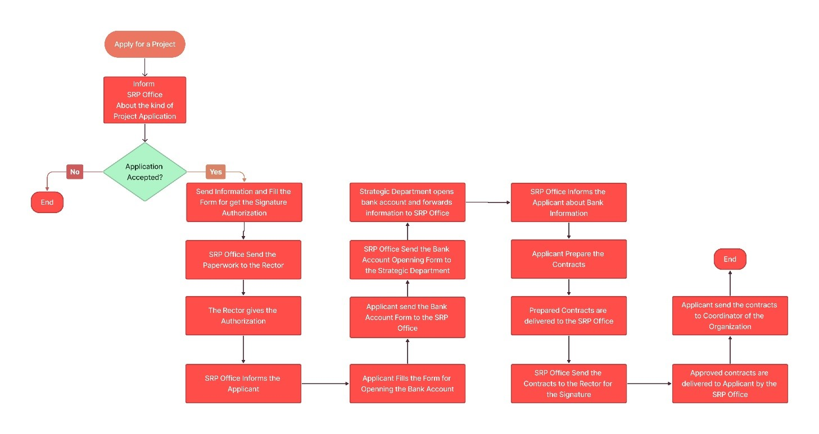

(Figure 2.1: current Project Initiation flowchart)

1. **Payments of Staff**

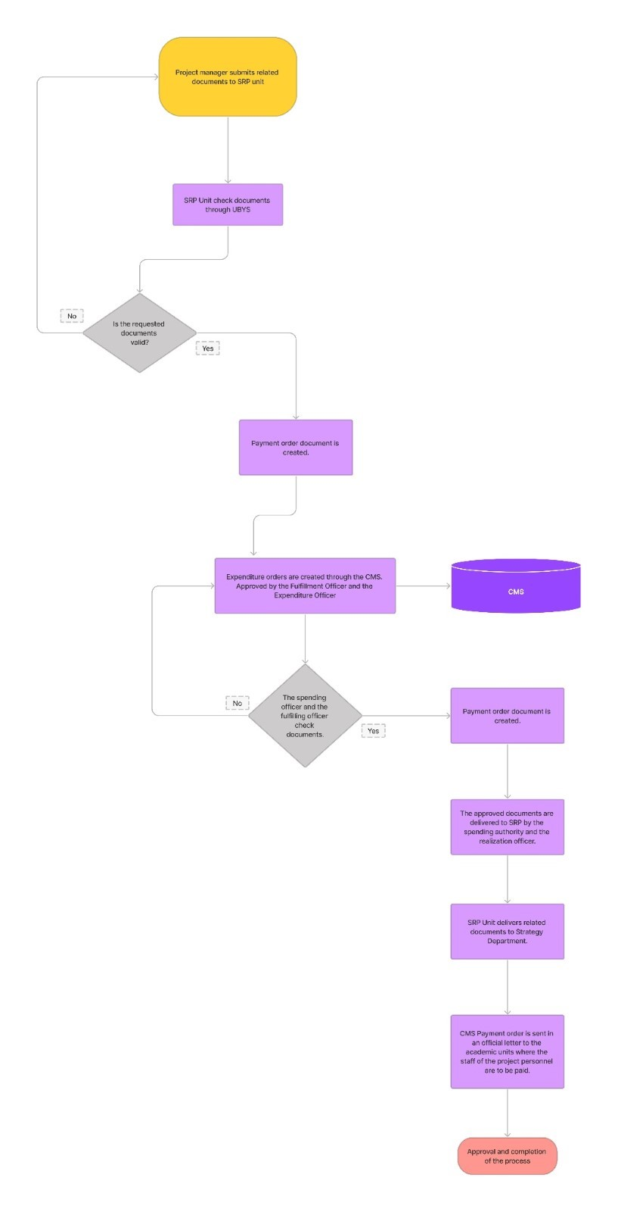

(Figure 2.2: current Payments of Staff flowchart)

1. **Payments of Travel**

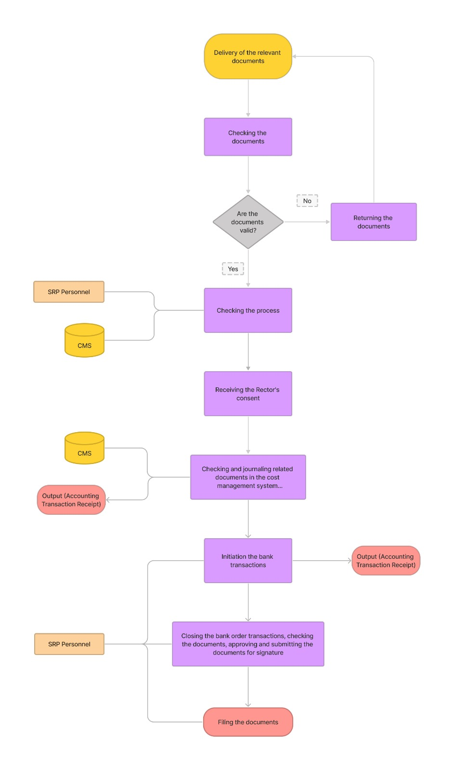

(Figure 2.3: current Payments of Travel and Events flowchart)

1. **Exceptional Cost Requests**

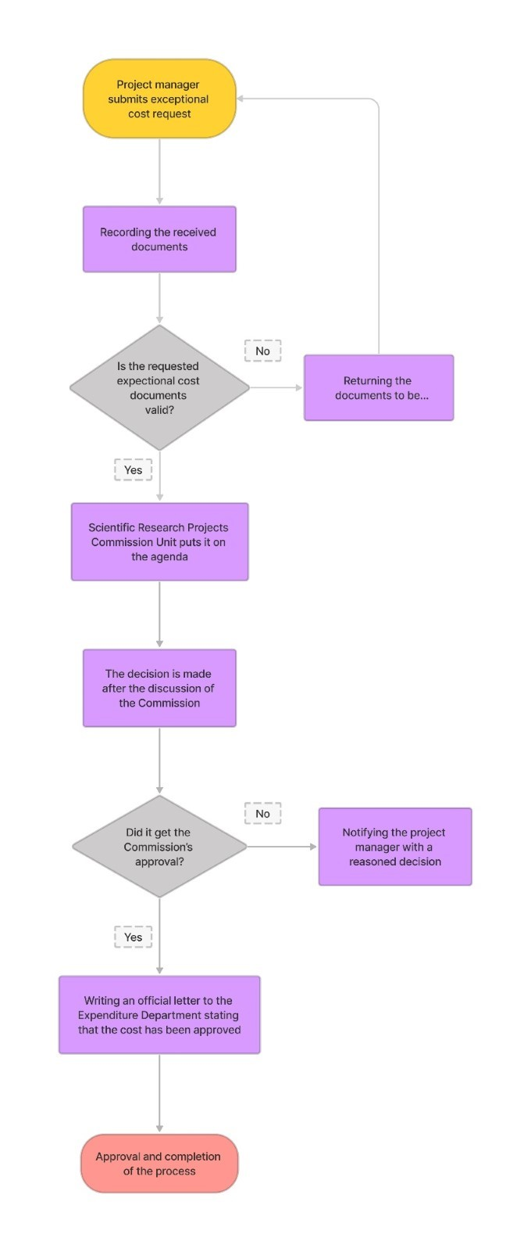

(Figure 2.4: current Exceptional Cost Requestsflowchart)

1. **DIGITALIZATION EXPLANATION**

The use of enterprise information systems (EIS) has become increasingly popular due to its specialized nature; it provides executives of businesses with necessary analytical capabilities and strategic information that enhance decision-making abilities. In today's day and age of technology, Digitalization features have become one of the most crucial aspects of EIS functionalities across organizations because it enhances efficiency within the organizational operations. Among the various digitalization features present in the EIS systems can be broadly divided into multiple categories such as data integration, data analysis/reporting, and workflow and process automation.

Data Integration provides collecting data from various resources. Collecting data from different sources both internal and external also further consolidates them into one platform through techniques such as ETL program logic ensuring the quality status of raw datasets before forwarding them for analysis purposes.

Automated tools create a better environment for data analysis. These resources enhance decision-making with collected data. Outputs could create meaningful judgments while searching for innovative solutions within the university. Decision-makers could improve their decision-making and easily recognize new opportunities through these outputs.

Digitalization of workflows also eliminate the process of paperwork. Automation will increase the efficiency of the process since the process gets purified from the human touch. When something gets done manually, the application process takes longer than it should and wastes time for participants and authorities within the university. In addition to that, using hard copies also slows the general process. Corporating digitalization into international projects with document storage, notifications, and approval actions will improve the current system's efficiency. Since the project applicants have trouble when it comes to international projects. Apart from the already made or in-work projects, the system should also be available for new international project applicants. Having an integrated module in the system can eliminate paper works, and both the applicants and the authorities could follow the process of their projects online.

1. **FIGURES**
2. **Use Cases**

Use case modeling is the analysis and design of all the steps followed to realize a scenario or business technique in the system. Pre-prepared flowcharts are useful when preparing use cases. While preparing these use cases, we considered four main situations: Initiation of a project, payments of staff , payments of travel and events and additional budget. While preparing the use cases, we first determined the scope, then determined the primary actor and created the "preconditions" section where we consider the conditions before starting the steps of a scenario. Then we created the steps of the "main success scenario" in line with the flowcharts we prepared in advance. If there are steps that can have two different results in a possible scenario, we specified them in the extensions section. Finally, we created the events that took place after all these processes were done in the "postcondition" section.

1. **Project Initiation**

|  |  |
| --- | --- |
| **Use Case Name** | Initiation of Projects |
| **Scope** | Start a New Project |
| **Level** | User Goal |
| **Primary Actor** | Project Manager |
| **Preconditions** | 1. Project Manager login to the UIMS 2. Apply for a project |
| **Main Success Scenario** | 1. Project Manager enters the necessary information of the project into the UIMS 2. Application accepted 3. Project Manager updates the status of the project in the system 4. PM fill and upload the documents to the eDMS to get authorization from Rector 5. Rector gives the authorization 6. PM fill and upload the document to the eDMS to opening the bank account 7. Strategic Department gets the documents via eDMS and send to the bank. 8. Bank account is opening and forward information to Strategic Department 9. Strategic Department processes into SRP about bank information 10. PM prepare contract for the project team and upload to eDMS to get authorization from Rector 11. Rector gives the authorization through eDMS |
| **Extensions** | 2a. Application declined, and flow ended |
| **Post condition** |  |

1. **Payments of Staff**

|  |  |
| --- | --- |
| **Use Case Name** | Payments of Staff |
| **Scope** | To Make Salary Payments to Personnel |
| **Level** | User Goal |
| **Primary Actor** | Project Manager |
| **Preconditions** | 1. Project Manager login to the UIMS |
| **Main Success Scenario** | 1. Project Manager submits related documents to SRP unit 2. SRP unit check documents through UIMS 3. Creating payment order document 4. Create expenditure orders through the CMS. Approved by the Fulfillment Officer and the Expenditure Officer 5. Check documents by the spending officer and the fulfilling officer 6. Create payment order document 7. The approved documents are delivered to SRP by the spending authority and the realization officer 8. SRP Unit delivers related documents to Strategy Department 9. CMS Payment order is sent in an official letter to the academic units where the staff of the project personnel are to be paid 10. Approval and completion of the process |
| **Extensions** | 2a. Upload Missing File   1. Go to step 1     5a. Faulty documents   1. Go to step 4 |
| **Post condition** | The system creates payment records for each staff member |

1. **Payments of Travel and Events**

|  |  |
| --- | --- |
| **Use Case Name** | Payments of Travel |
| **Scope** | Payment Of Travel Expenses Incurred |
| **Level** | User Goal |
| **Primary Actor** | Project Manager |
| **Preconditions** | 1. Project Manager login to the UIMS 2. Select project |
| **Main Success Scenario** | 1. Submit relevant documents to the system 2. System checks and approvals the valid documents 3. Checking the process by the CMS and SRP personnel 4. Request the Rector’s consent 5. Receiving the consent 6. Checking and journaling related documents in the cost management system 7. Accounting transaction receipt 8. Initiation the bank transactions 9. Receive accounting transaction receipt 10. Check bank order transactions 11. Closing the bank order transactions, checking the documents and approve and submit the documents for signature by SRP Personnel 12. Fill the documents |
| **Extensions** | 2a. Upload Missing File   1. Go to step 1 |
| **Post condition** |  |

|  |  |
| --- | --- |
| **Use Case Name** | Payments of Travel |
| **Scope** | Payment Of the Travel Expenses for A Project |
| **Level** | User Goal |
| **Primary Actor** | SRP Personnel |
| **Preconditions** | 1. Select project |
| **Main Success Scenario** | 1. Update the process 2. Initiate the bank transactions 3. Receive the accounting transaction receipt 4. Closing bank order 5. Approval of the closure of the bank order 6. Checking documents 7. Approval of the documents 8. Submit the documents 9. Completion of process |
| **Extensions** | 2a. Upload Missing File   1. Go to step 1 |
| **Post condition** |  |

1. **Exceptional Cost Requests**

|  |  |
| --- | --- |
| **Use Case Name** | Exceptional Cost Requests |
| **Scope** | Provision of Additional Budget |
| **Level** | User Goal |
| **Primary Actor** | Project Manager |
| **Preconditions** | 1. Project Manager login to the system 2. Enter the additional budget tab 3. Fill the exceptional cost request form |
| **Main Success Scenario** | 1. Project manager submits exceptional cost request 2. Submit requested documents 3. System checks and approvals the valid documents 4. Scientific Research Projects Commission Unit puts it on the agenda 5. SRP commission present the decision of request 6. Write official letter to the Expenditure Department 7. Approval of the Exceptional Cost |
| **Extensions** | 3a. Upload Missing File   1. System returns rejection message 2. Go to step 2              5a. Did not receive approval   1. Notifying with a reasoned decision |
| **Post condition** |  |

1. **System Sequence Diagrams**

Previous semester, we have prepared flowcharts of current system. With this study, we have encountered what is needed for the automation and integration of the SRP module of international projects. As a result of this study, we determined which steps need to be taken in terms of integration of the new module in the current system. Since the new module will be integrated to the current system, we need to determine which automation process should be included and how it works. We have four main flows that project applicants face with: Initiation of a project, payments of staff, payments of travel and additional budget. We have designed system seequence diagrams based on this needed flows.

According to the textbook Applying UML and Patterns: An Introduction to Object-Oriented Analysis and Design written by Craig Larman; A System Sequence Diagram (SSD) is a snapshot of a system that shows the events that happens between the external actor and system within the scope of a use case scenario. SSDs can be used in several processes such as system design and implementation, use case method, behavioral modeling, and requirement analysis.

The symbols used in the beginning of the system sequence diagrams are the stick figure that represents the external actor and box that represents the system. There are also symbols inside of the diagram such as solid arrow that represent the events that was send by the external actor, dashed arrow that represent the return value from the system to the actor, a big box outlining the lines can represent several things as loop or alternative scenario.

1. **Initiation of Project**

The Initiation of project process consists of a series of manual processes between the Applicant, SRP office, Rectorate, Strategy Department and the bank.

The project application is submitted to the SRP office by the applicant and the required forms are physically submitted to the SRP office. The SRP office takes the necessary documents to the rectorate for approval and the SRP office physically receives the documents approved by the rector and informs the user about the status.

The applicant then fills in the necessary documents to open a bank account and submits them to the SRP office. The SRP office then delivers the documents to the Strategic Department and the Strategic Department opens a bank account and this information is returned to the applicant.

Finally, the applicant physically submits the contract to the SRP office, the documents again go to the rector for signature for approval and the approved documents are delivered to the applicant by the SRP office.

In order to facilitate and accelerate this whole process, it would be a great benefit for both the applicants and the university if the whole process is optimized and done online.

With the whole process being carried out through UIMS, the applicant will now be able to make the information about the project and the application request directly through the system, upload the necessary documents to the same system, and the SRP office will be able to easily carry out the necessary follow-up through the system. The documents that need to be approved will go to eDMS (Electronic Document Management System) and the documents that need to be approved by the Rectorate will be uploaded to the same system (eDMS) after approval and the applicant will be able to follow the whole process through the system.

When the process for creating a bank account is also done through the system, after the applicant uploads the necessary forms to UIMS, the Strategic Department receives the necessary documents directly through the system, creates a bank account and uploads the bank account information to the same system. The applicant can easily access the bank account information through the system.

The Applicant uploads the contract to eDMS for approval, as a last step, and the documents that need to be approved by the Rectorate are uploaded to the same system (eDMS) after approval.

This is exactly what is intended in this SSD. As can be seen in the SSD, optimizing the whole process in this way will enable applicants to follow the process much more easily and save time. Likewise, having the whole process run through the system will allow different departments of the university to easily access the same information at the same time, making the process much easier overall.

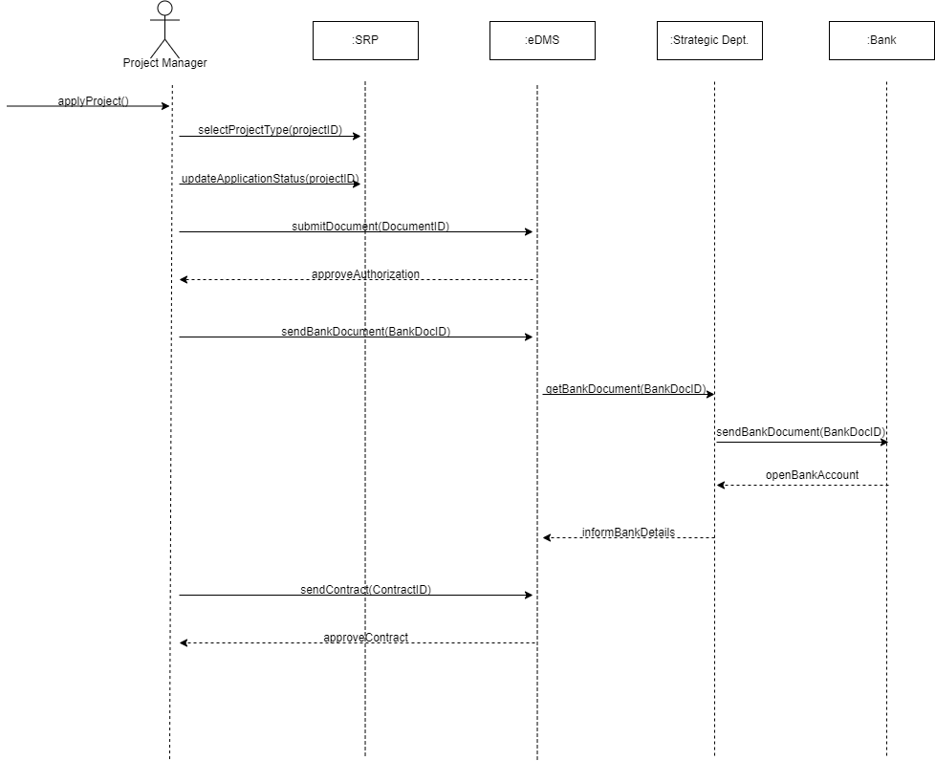

1. (Figure b.1: System Sequence Diagram of **Initiation of Project**

)

1. **Payments of Staff**

Based on flowcharts that presents the manual flow of related action steps are:

1. Project manager submits the required documents to the SRP unit.
2. SRP unit checks the documents through UIMS.
   1. If the documents are not valid, project manager need to apply again.
3. After checking documents validation, SRP unit creates payment order.
4. Expenditure orders are created through CMS.
5. Orders are approved by Fullfillment Officer and Expenditure Officer through CMS.
   1. If the documents are not approved, documents are send back to the SRP unit to check again.
6. Payment order document is created.
7. The order document is delivered to the SRP by Realization Officer and Spending Authority.
8. SRP unit delivers the order document to Strategy Department.
9. Payment order is sent to academic units where the academic personnel are to be paid by letter.
10. Completion of the process.

The need for automation appears on the first step. If the SRP unit can browse the documents on UIMS, why project manager deliver the documents as physical. Since, SRP unit need to upload the documents on the UIMS. However, project manager needs to apply it through UIMS to eliminate paperwork. Afterwards, payment orders doucments are handled on CMS, mainly. On the other hand, related documents are sent departments manually. On the one hand, departments can check these documents on UIMS. Departments can approve or declien the processes on the system. In addition to that, both project manager and departments cang et notified by specific actions such as receiving a document or status of a process(declined or approved). At the end, project manager receive letter for confirmation of the porject application. Rather than that, project manager can get notified in the system and receive the letter online.

As SSD shows, the automation process should be taken as it is:

1. Project manager submit the documents to SRP module in UIMS.
2. SRP unit check the process.
   1. If the documents are not valid, project manager need to apply again (Loop).
3. After approval process SRP unit deals with payment order documents through CMS.
   1. If the documents are not valid, SRP unit check the documents again (Loop).
4. Payment orders are created.
5. Related documents are sent to Strategy Department.
6. Strategy department create the order document.
7. Project manager receive the approval of the project.

With these integrations, the flow is decreased by 3 steps and paperworks are eliminated. Project applicants must submit the documents on UIMS – SRP module.

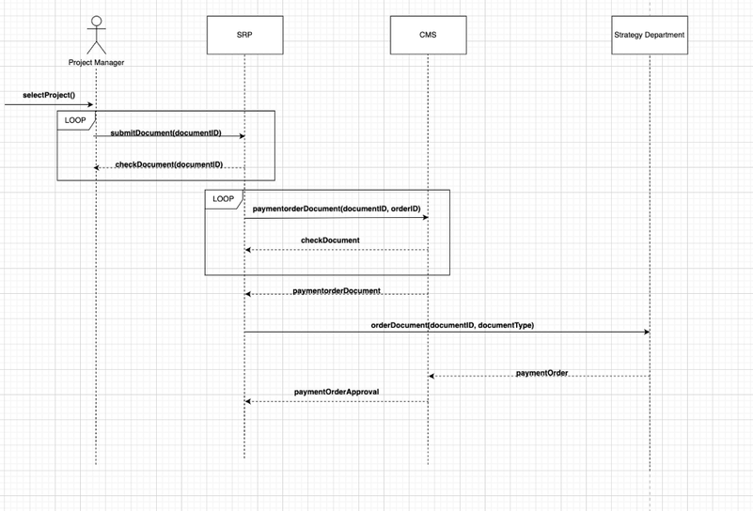

1. **Payments of Travel and Events**

Based on the current scenario, project managers and team members have to follow these steps in order to get payments for travel and events:

1. The project manager or team member delivers the hard copies of the required documents to the SRP unit.
2. SRP personnel checks the documents' validity.
3. If the documents are not valid, the project manager or team member needs to fix the documents and starts the process again.
4. After the SRP personnel checks and accepts the documents, the documents get sent to the Rector.
5. The documents get checked by the Rector in order to receive Rector’s consent.
6. After receiving Rector’s consent, related documents get checked and journaled in the Cost Management System (CMS).
7. SRP personnel starts to initiate the bank transactions.
8. SRP personnel works with bank initiations: transactions, account info, and transaction receipts.
9. SRP personnel closes the bank transactions.
10. SRP personnel approves and submits the documents for signature processes.
11. After receiving signatures, the process is completed.

With the new SRP System International Projects module, instead of going back and forth with the SRP, the project manager uploads the required documents to the new SRP module. Waits for the documents to get accepted and for the document process to change. After the documents get accepted, the said documents are sent to the Rector by the SRP unit via an Electronic Document Management System (EDMS). After getting the Rectors' electronic signature, costs are evaluated using the Cost Management System (CMS). SRP unit completes bank transactions and the project manager follows every step with the help of the new SRP module. After the bank transaction gets completed, the process ends.

In other words, with the new SRP System International Projects module, project managers and team members will follow these steps:

1. The project manager or team member uploads the required documents to the system.
2. SRP personnel checks the documents' validity.
3. If the documents are deemed not valid, the project manager or team member needs to fix the issue with the documents and re-upload them to the system.
4. After the SRP unit checks and validates the documents, the documents get sent to the Rector using EDMS.
5. Documents get checked by the Rector in order to receive Rector’s consent via EDMS.
6. After receiving Rector’s consent, related documents get sent to Cost Management System (CMS).
7. SRP personnel starts to initiate the bank transactions.
8. SRP personnel works with bank initiations: transactions, account info, and transaction receipts.
9. Then, the SRP personnel closes the bank transactions and approves and uploads the documents and receipts for signature processes.
10. After receiving signatures, the process is completed.

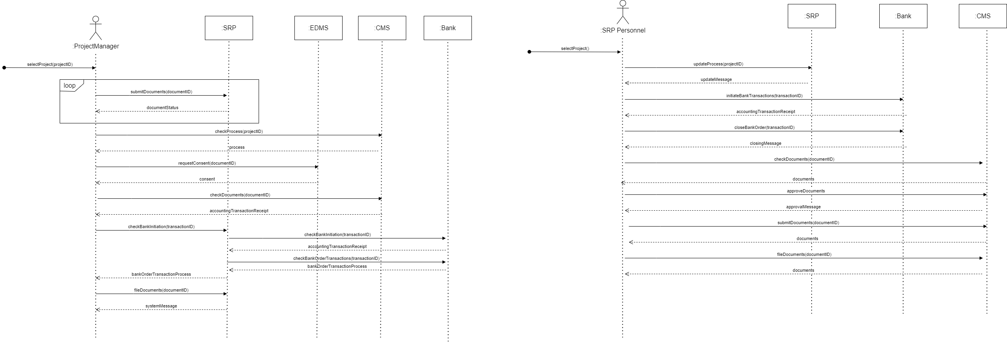



1. **Exceptional Costs**

When creating SSD of the additional budget, I based it on the use case modeling that we prepared earlier. The project manager, who is the primary key, first creates an application form for the additional budget request through the UIMS system and then uploads the necessary documents to complete the application. If these documents are missing, the PM uploads the missing documents back into the system and the SRP raises this issue with the commission to review the additional budget request. Once the committee meets, it announces its decision and if the decision is approved, the SRP writes an official letter to the spending unit that the additional budget request has been approved, thereby approving the supplementary budget request. If the SRP commission rejects the request, it informs the Project Manager of the rejection, and the flow ends.

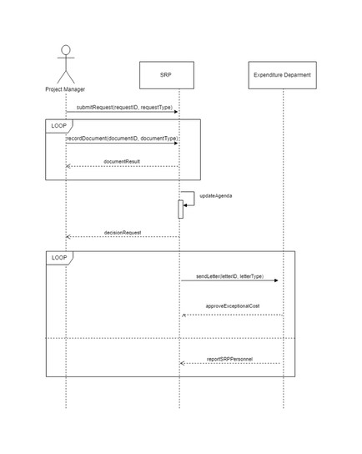

1. **Sequence Diagrams**

The textbook UML Distilled: A Brief Guide to the Standard Object Modeling Language defines Sequence Diagrams (SD) as diagrams that show the messages, the interaction of objects, and components within the use-case scenario. SDs have several elements as found message (the message in the beginning that triggers the process), vertical lifelines of objects, and a solid arrow that contains information such as function and related parameters. Just like system sequence diagrams (SSD), sequence diagrams are also used for several processes such as system design and implementation. Creating a sequence diagram is the step where we start defining which classes we will need while preparing the class diagrams and defining their attributes.

1. **Project Initiation**

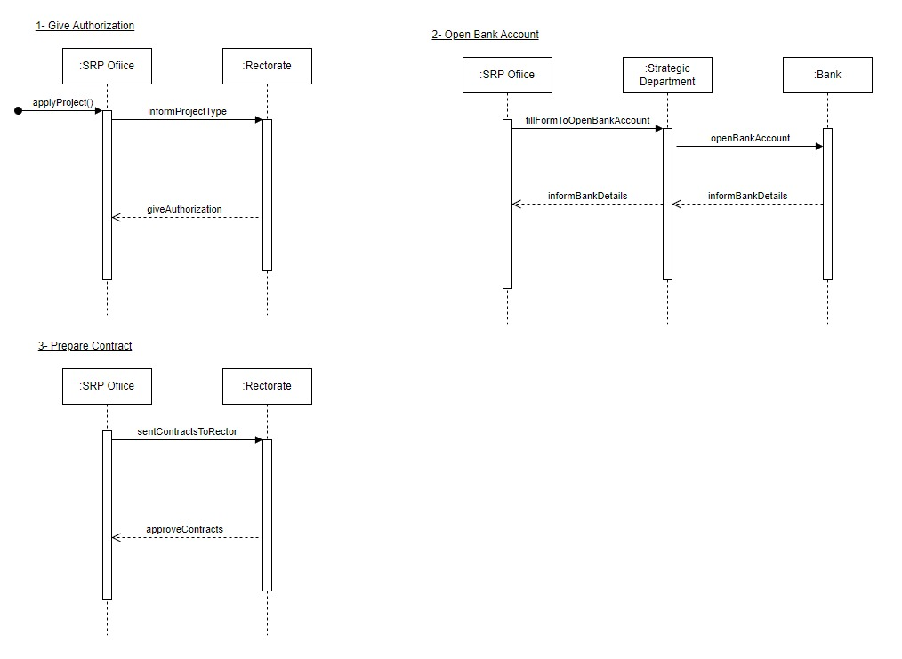

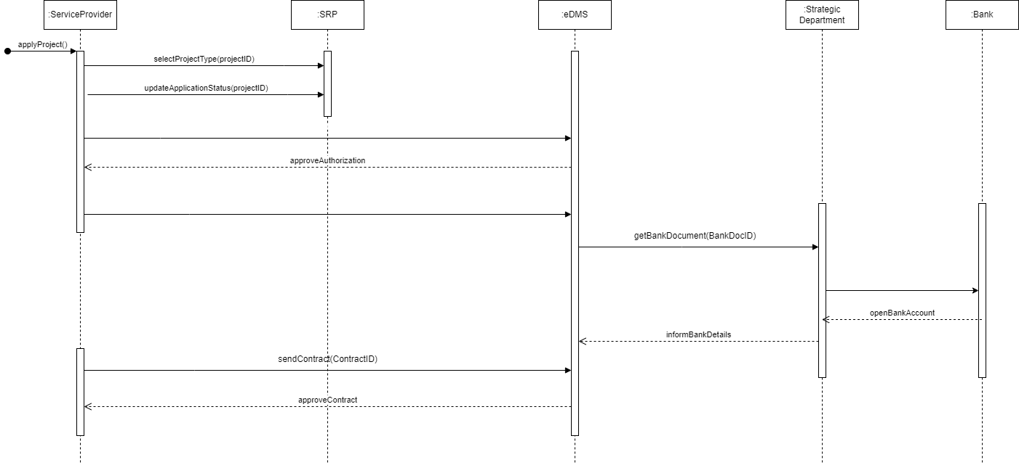

1. **Payments of Staff**

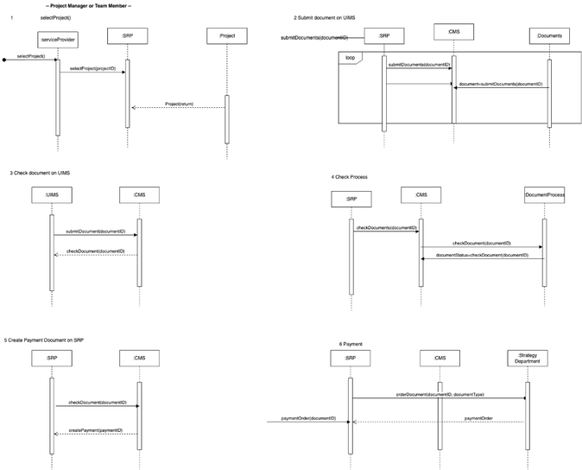

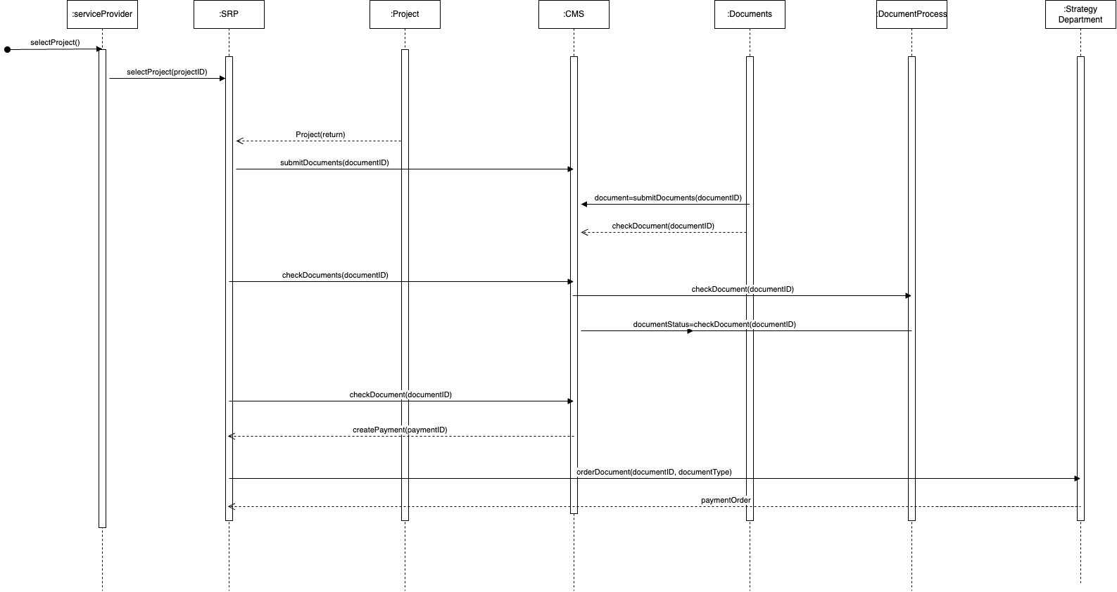

1. **Payments of Travel and Events**

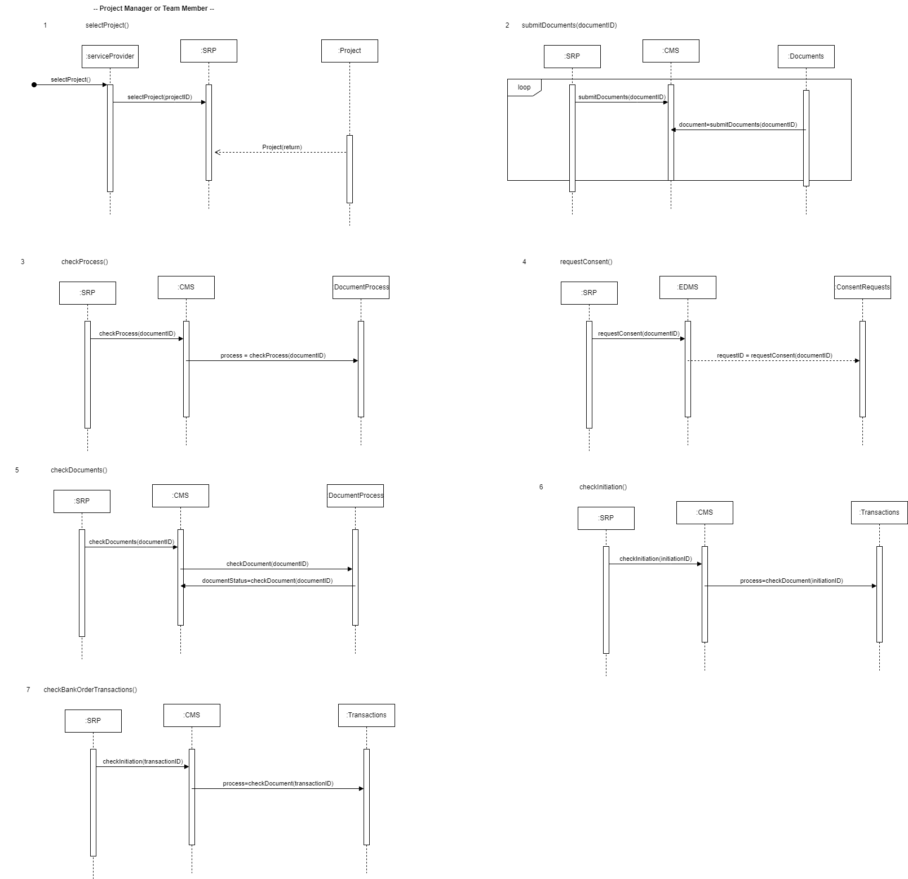

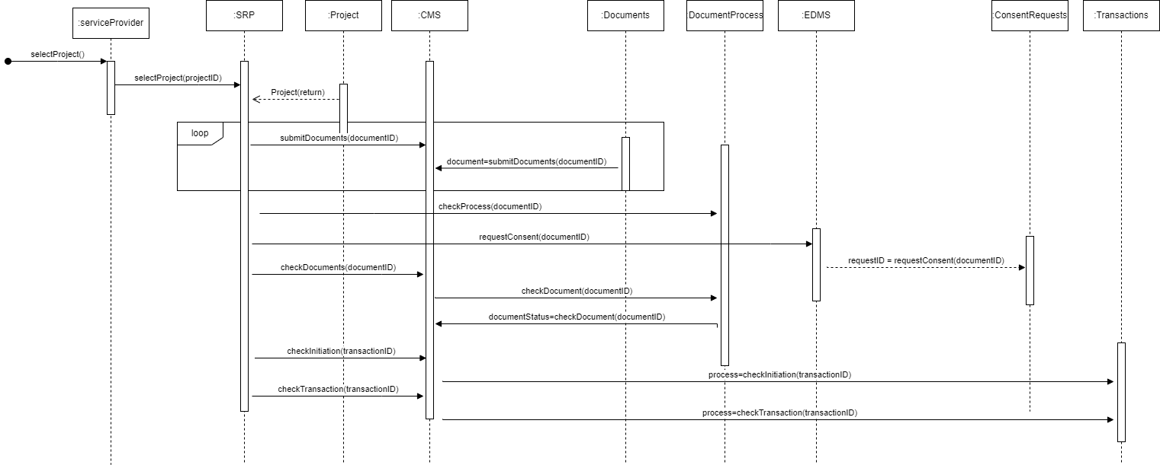

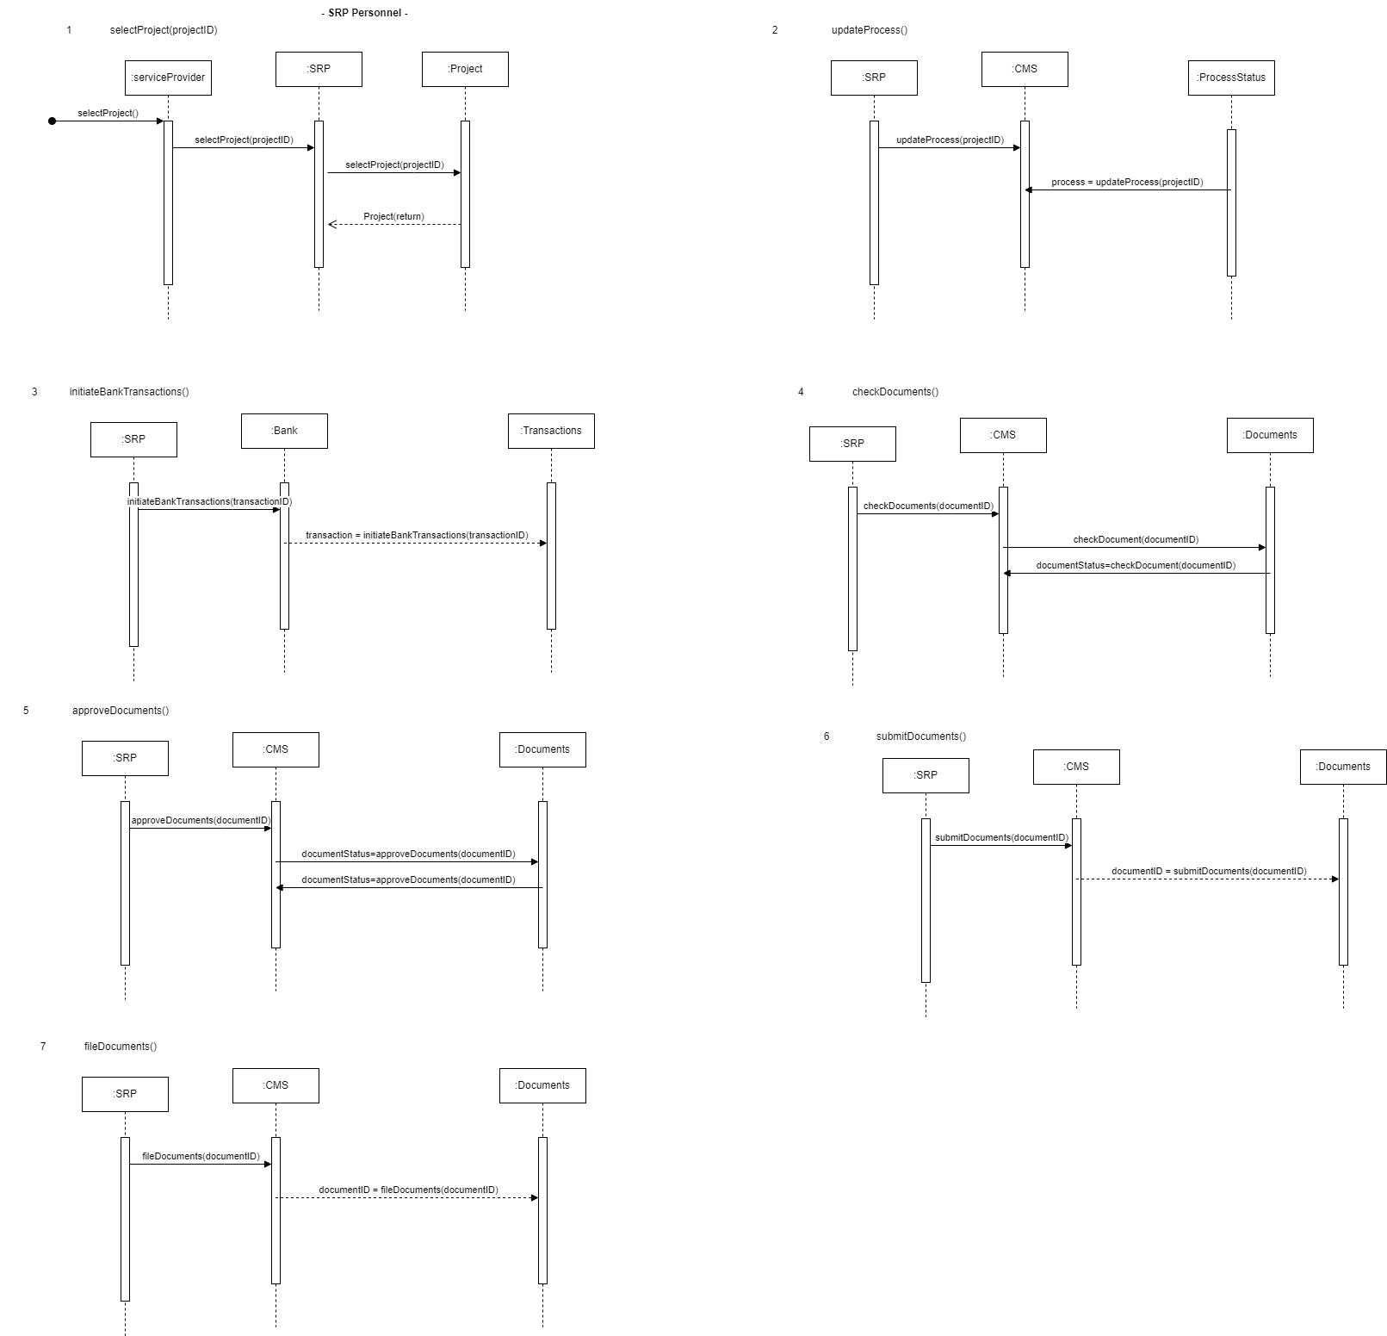

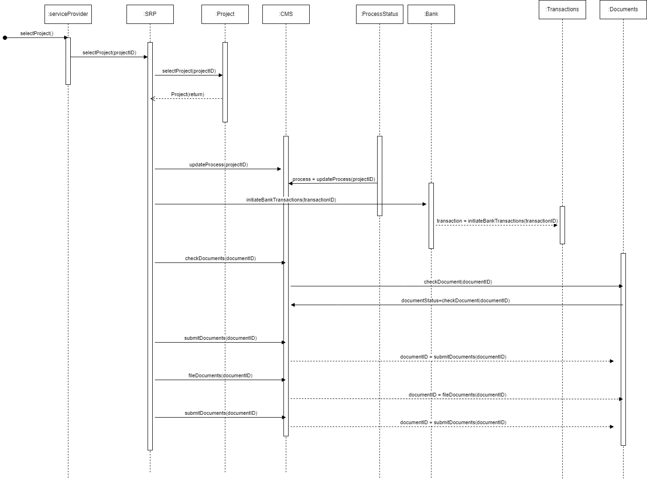

1. **Exceptional Costs**

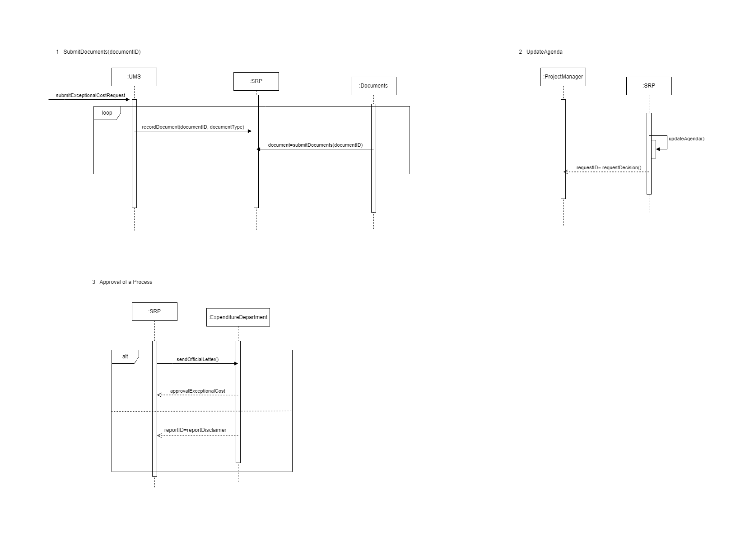

1. **Class Diagrams**

According to the textbook UML Distilled: A Brief Guide to the Standard Object Modeling Language, a class diagram is a static diagram that contains the object types, relationships, object attributes, and sometimes object operations, and the general structure of a system. In other words, class diagrams show a class is connected to another different class and what those classes contain.

Class diagrams contain several elements such as properties, attributes, objects, and associations. Properties are the drawing of tables that contains information such as the name of the table, the attributes of the table, the type of the data, etc. Associations show the relationships within the classes. Associations are shown as a solid line that connects the classes with an arrow. Multiplicity is the degree of the relationship. For example, if multiplicity is shown as 1 it means the object can only contain 1 of the object that the line goes to. In other words, a student can only have one student mentor. If the multiplicity is shown as 1 .. * that means the object can contain 1 or an infinite amount of the object that the line goes to. In other words, a student mentor can have multiple students.

1. **Project Initiation**

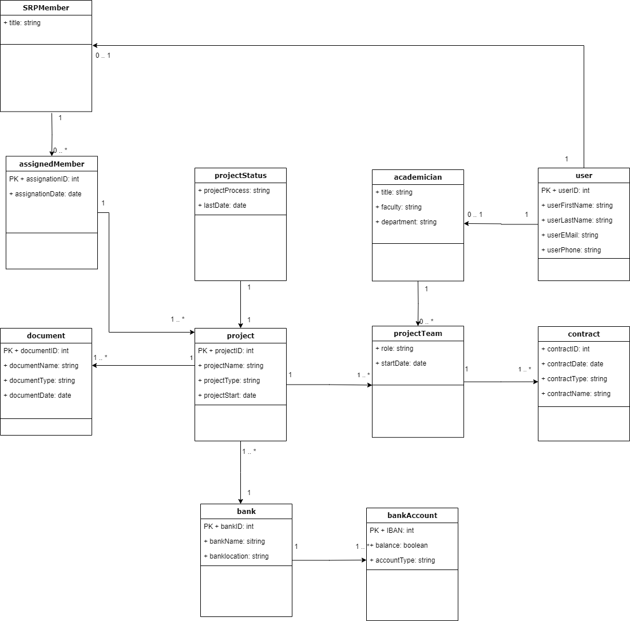

1. **Payments of Staff**

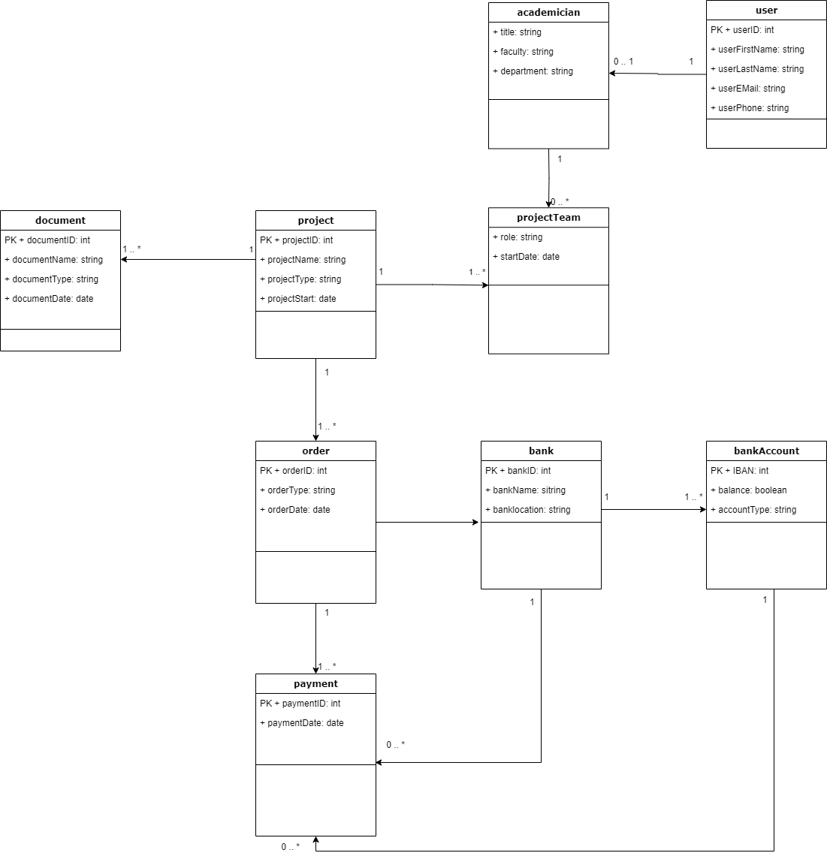

1. **Payments of Travel and Events**

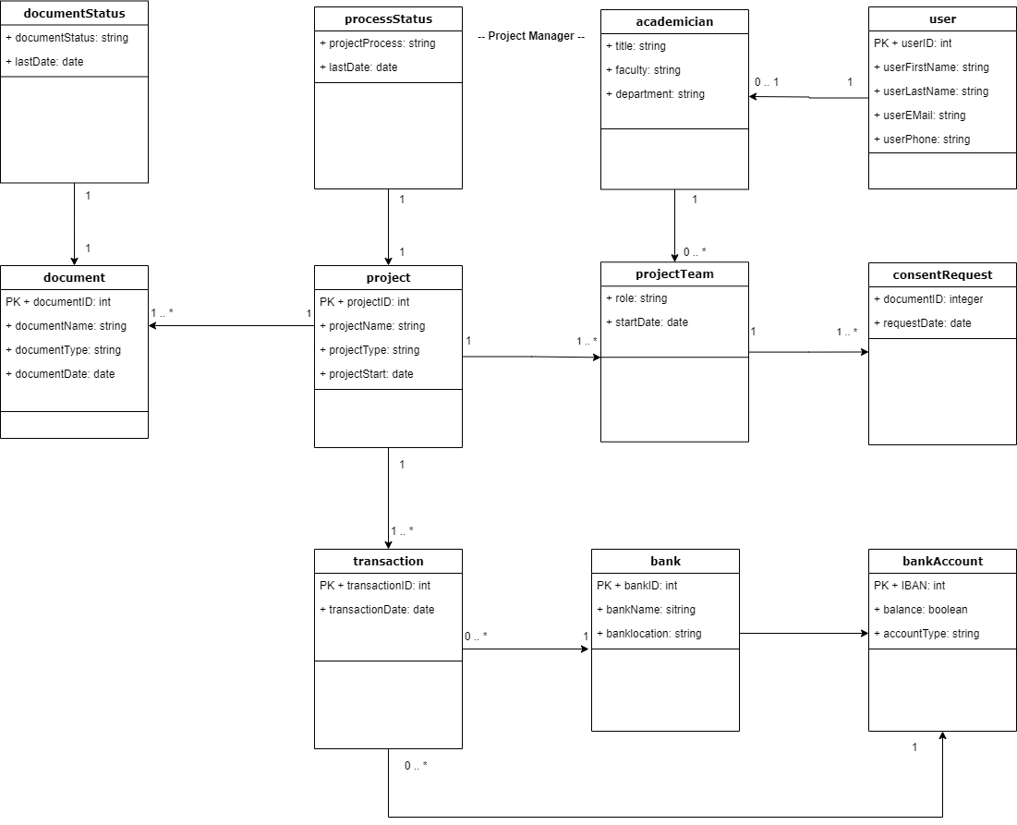

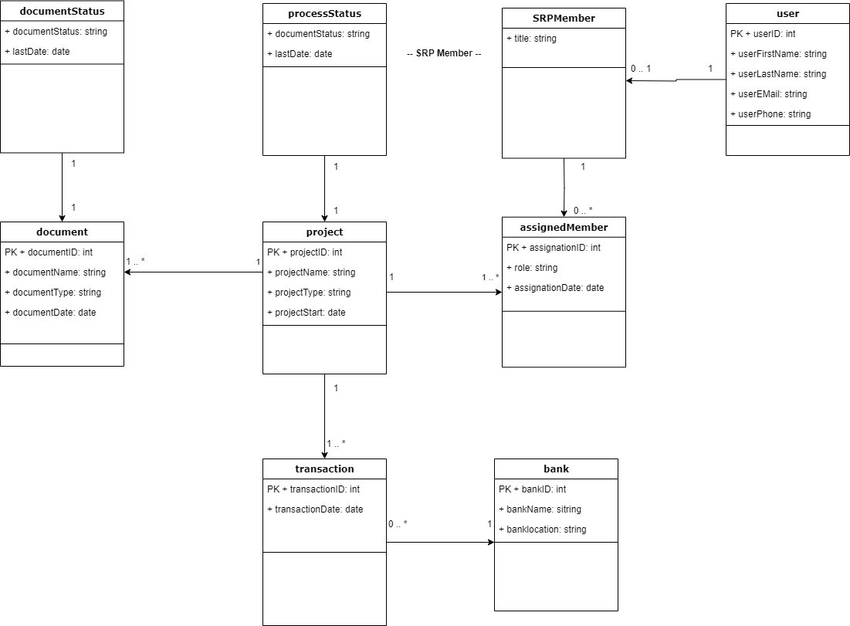

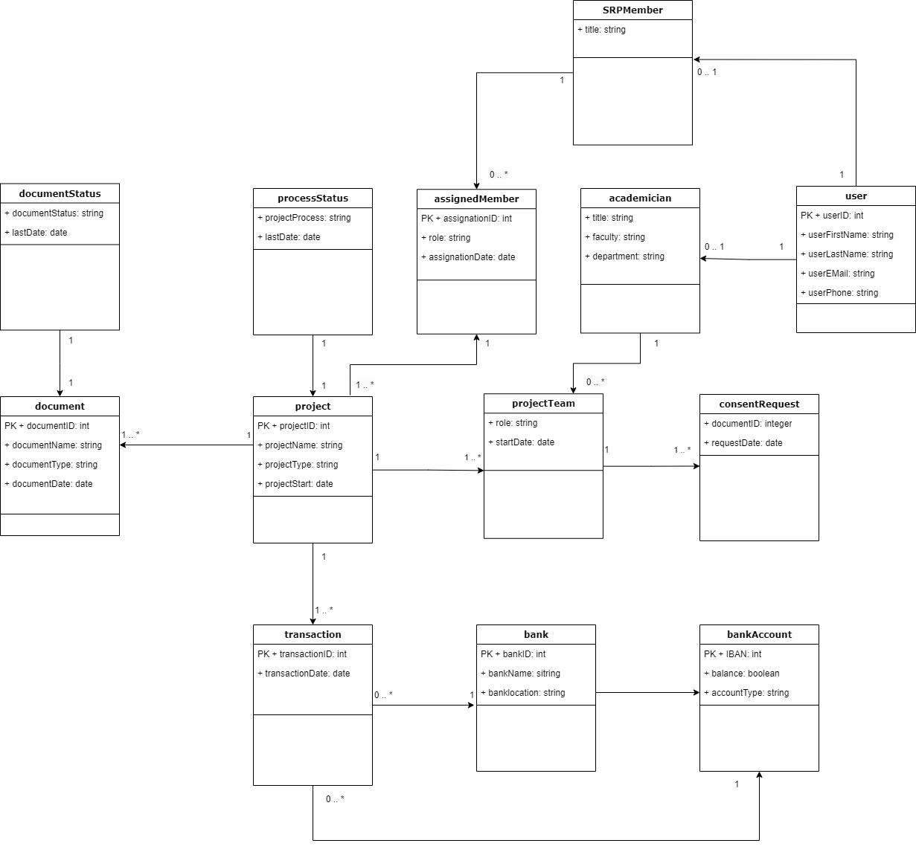

1. **Exceptional Costs**

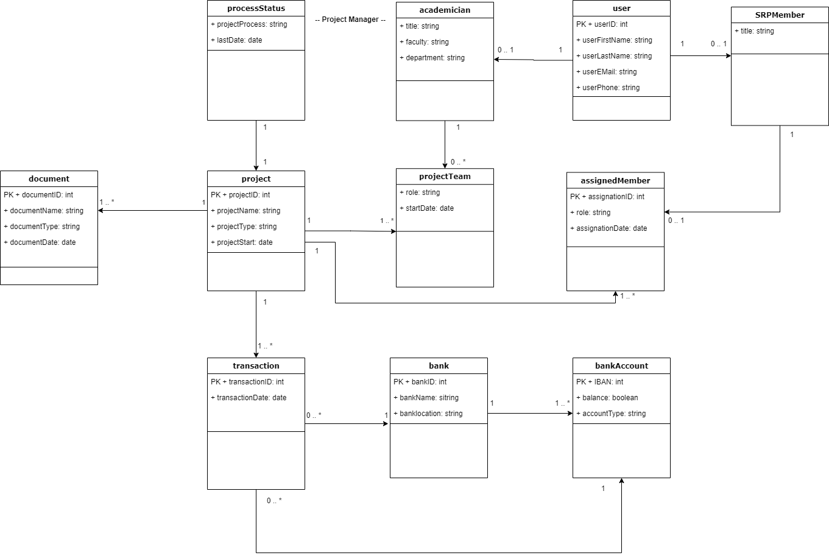

**All Class Diagrams**

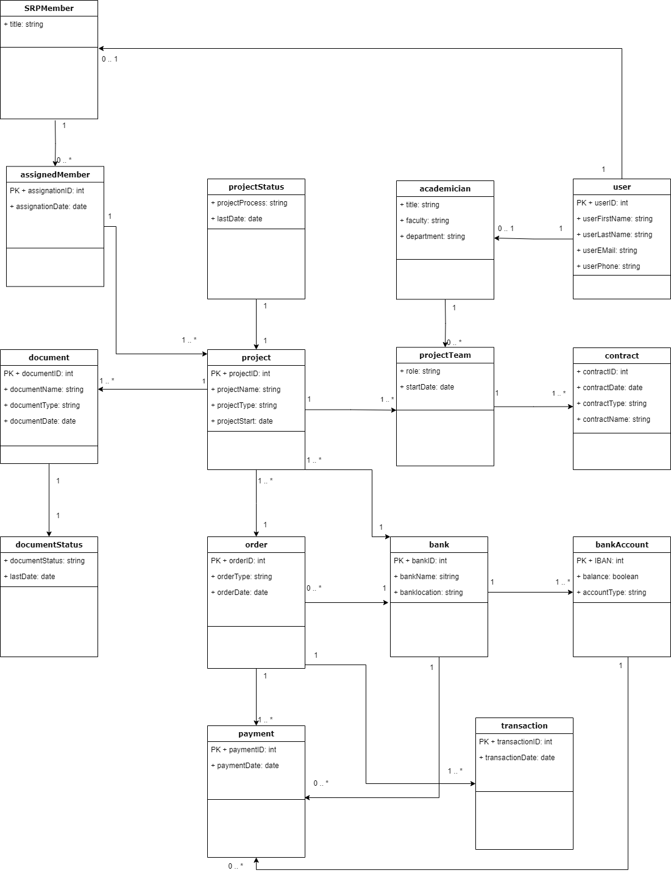

1. **3NF**

Coronel, et al. (2017) describe normalization as the process of defining class structures and cleaning attributes in order to get rid of data redundancies and anomalies. The normalization process has several degrees. In the first normal form (1NF), data tables are defined and contain the defining primary keys. In the second normal form (2NF), data tables should cover 1NF requirements and also should not contain partial dependencies. In the third normal form (3NF), data tables should cover 2NF requirements and should not contain transitive dependencies. In other words, in the end, data tables should not have repeated attributes and only the keys can depend on each other.

1. **Project Initiation**

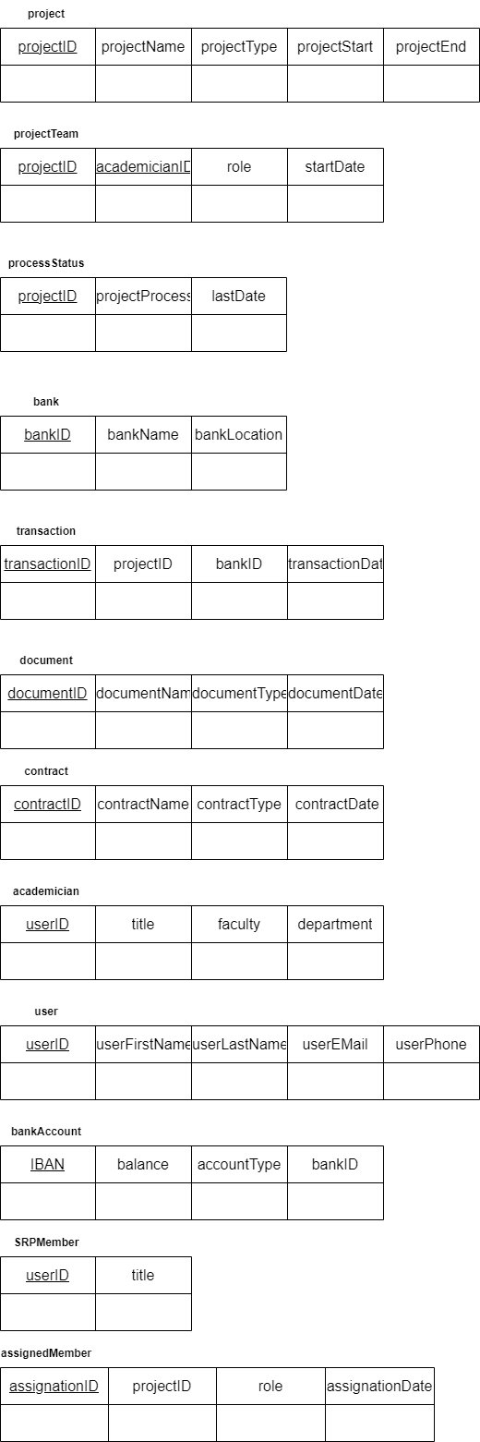

1. **Payments of Staff**

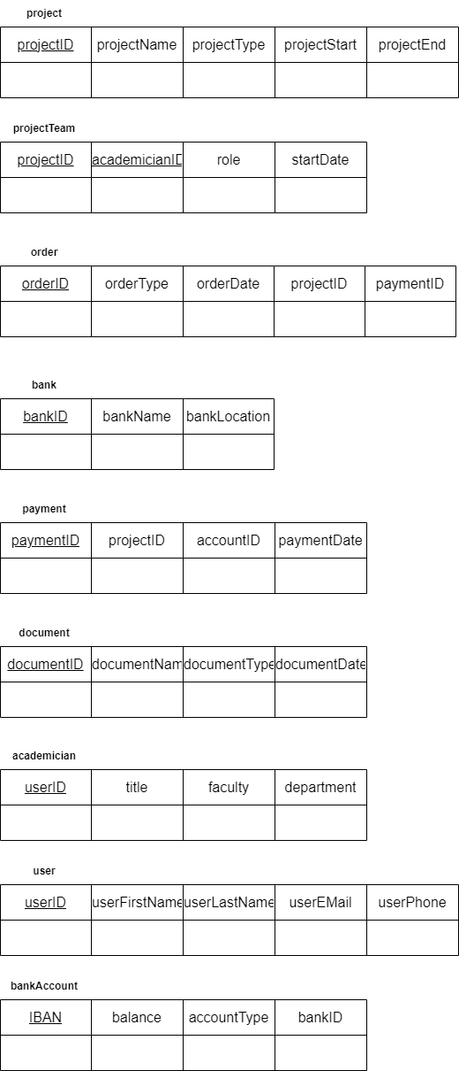

1. **Payments of Travel and Events**

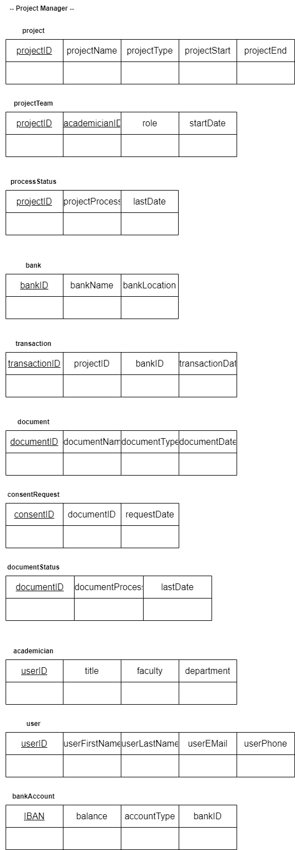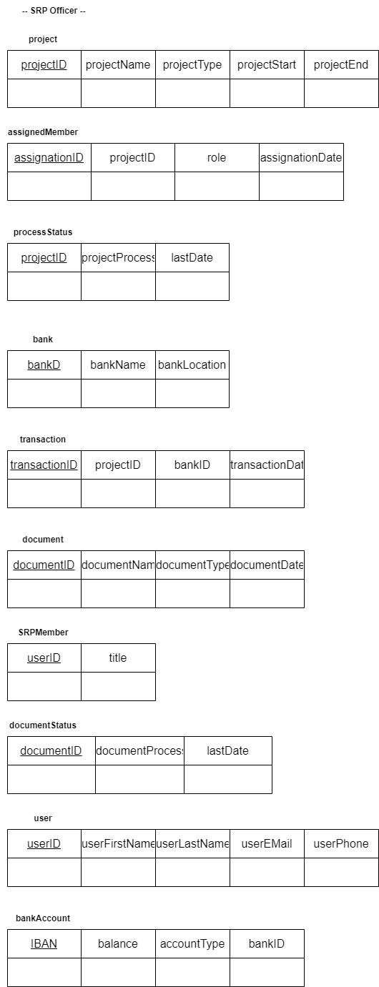

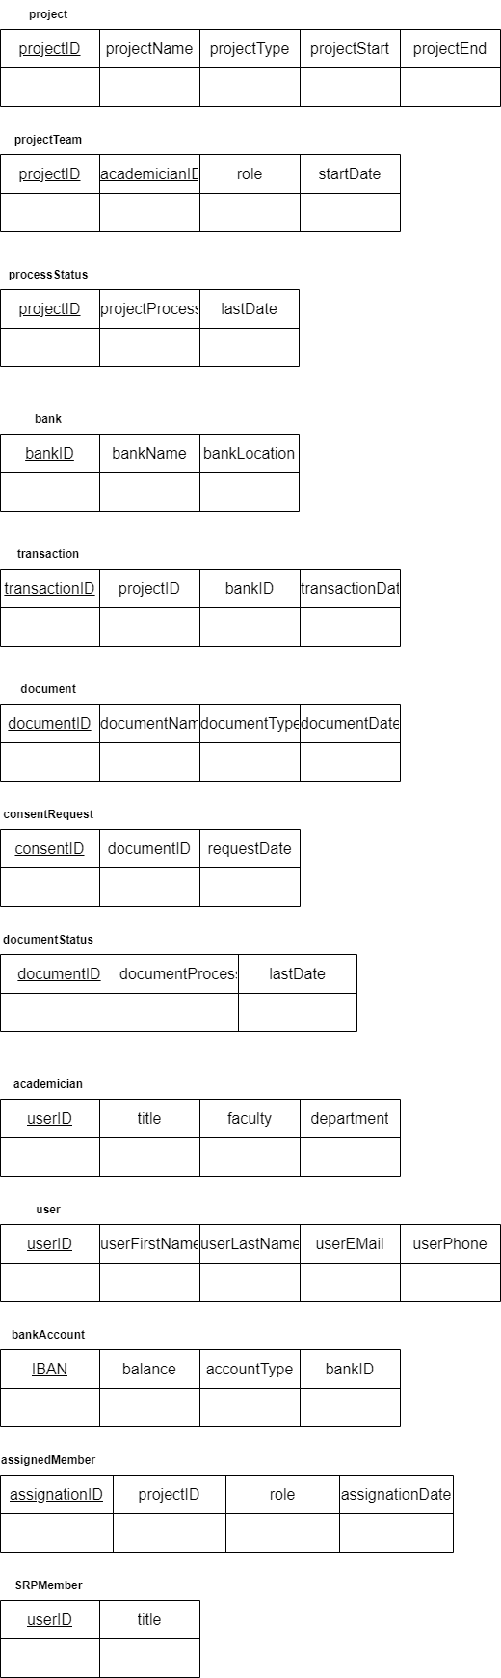

1. **Exceptional Costs**

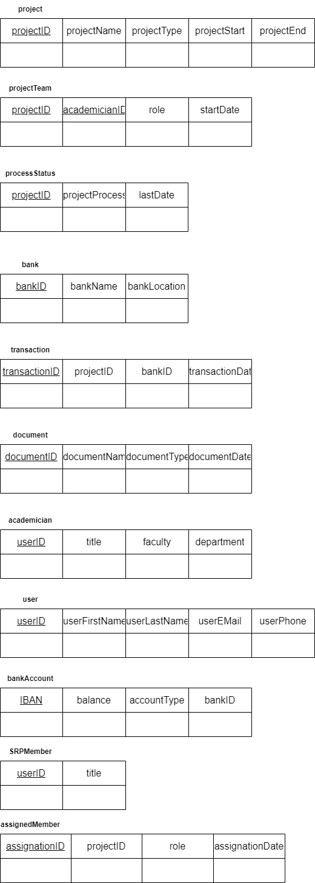

1. **Data Dictionary**

Data dictionaries are tables that contain information about each class. A data dictionary contains elements such as the table name, description of the table, name of the attributes, type of the attributes, whether that attribute is a primary key or not, whether the system can allow that attribute to have a null value, and the description of the attribute. Data dictionaries help us understand the tables better, it shows us which attributes covers what kind of data and what type of data we can use while adding data to the tables.

1. **Project Initiation**

|  |  |  |  |  |  |
| --- | --- | --- | --- | --- | --- |
| **Table Name** | | Document | | | |
| **Description** | | A document is an official record that contains information | | | |
| **Attributes** | | | | | |
| **Name** | **Type** | | **Key** | **Allow Nulls** | **Description** |
| documentID | Integer | | True | False | ID of the document |
| documentName | String | | False | True | Name of the document |
| documentType | String | | False | False | Type of the document |
| documentDate | Date | | False | False | Date when the document was uploaded |

|  |  |  |  |  |  |
| --- | --- | --- | --- | --- | --- |
| **Table Name** | | Project | | | |
| **Description** | | A project is a collaborative structured work to achieve a selected goal via scientific methods | | | |
| **Attributes** | | | | | |
| **Name** | **Type** | | **Key** | **Allow Nulls** | **Description** |
| projectID | Integer | | True | False | ID of the project |
| projectName | String | | False | True | Name of the project |
| projectType | String | | False | False | Type of the project |
| projectStart | Date | | False | False | Date when the project was started |
| projectEnd | Date | | False | False | Date when the project is supposed to end |

|  |  |  |  |  |  |
| --- | --- | --- | --- | --- | --- |
| **Table Name** | | processStatus | | | |
| **Description** | | Process status is the current status of the project’s process | | | |
| **Attributes** | | | | | |
| **Name** | **Type** | | **Key** | **Allow Nulls** | **Description** |
| projectID | Integer | | True | False | ID of the project |
| projectStatus | String | | False | False | Current status of the project |
| lastDate | Date | | False | False | Date when the status was last updated |

|  |  |  |  |  |  |
| --- | --- | --- | --- | --- | --- |
| **Table Name** | | projectTeam | | | |
| **Description** | | Project team is the list of people that belongs to a project | | | |
| **Attributes** | | | | | |
| **Name** | **Type** | | **Key** | **Allow Nulls** | **Description** |
| projectID | Integer | | True | False | ID of the project |
| memberID | Integer | | True | False | ID of the project member |

|  |  |  |  |  |  |
| --- | --- | --- | --- | --- | --- |
| **Table Name** | | SRPMember | | | |
| **Description** | | SRP Member is the officer that works at the Scientific Research Projects department | | | |
| **Attributes** | | | | | |
| **Name** | **Type** | | **Key** | **Allow Nulls** | **Description** |
| userID | Integer | | True | False | ID of the user |
| title | String | | False | True | Title of the SRP Member |

|  |  |  |  |  |  |
| --- | --- | --- | --- | --- | --- |
| **Table Name** | | transaction | | | |
| **Description** | | A transaction is the processes related to a bank account | | | |
| **Attributes** | | | | | |
| **Name** | **Type** | | **Key** | **Allow Nulls** | **Description** |
| transactionID | Integer | | True | False | ID of the transaction |
| projectID | Integer | | False | False | ID of the project |
| accountID | Integer | | False | False | ID of the account |
| transactionDate | Date | | False | False | Date when the transaction was accured |

|  |  |  |  |  |  |
| --- | --- | --- | --- | --- | --- |
| **Table Name** | | Bank | | | |
| **Description** | | A bank is where money gets stored | | | |
| **Attributes** | | | | | |
| **Name** | **Type** | | **Key** | **Allow Nulls** | **Description** |
| bankID | Integer | | True | False | ID of the bank |
| bankName | String | | False | False | Name of the bank |
| bankLocation | String | | False | True | The place where the bank is located |

|  |  |  |  |  |  |
| --- | --- | --- | --- | --- | --- |
| **Table Name** | | assignedMember | | | |
| **Description** | | Assigned Member is the officer that is assigned to a project from the Scientific Research Projects department | | | |
| **Attributes** | | | | | |
| **Name** | **Type** | | **Key** | **Allow Nulls** | **Description** |
| assignationID | Integer | | True | False | ID of the user |
| projectID | Integer | | True | False | ID of the project |
| role | String | | False | False | Role of the SRP Member within the project |
| assignationDate | Date | | False | False | Date of the assignation |

|  |  |  |  |  |  |
| --- | --- | --- | --- | --- | --- |
| **Table Name** | | consentRequest | | | |
| **Description** | | The request of consent is a paper of request that allows people do something | | | |
| **Attributes** | | | | | |
| **Name** | **Type** | | **Key** | **Allow Nulls** | **Description** |
| consentID | Integer | | True | False | ID of the consent |
| documentID | Integer | | False | False | ID of the document |

|  |  |  |  |  |  |
| --- | --- | --- | --- | --- | --- |
| **Table Name** | | user | | | |
| **Description** | | User is the person who interacts with the system | | | |
| **Attributes** | | | | | |
| **Name** | **Type** | | **Key** | **Allow Nulls** | **Description** |
| userID | Integer | | True | False | ID of the user |
| userFirstName | String | | False | False | First name of the user |
| userLastName | String | | False | False | Last name of the user |
| userEMail | String | | False | False | E-mail of the user |
| userPhone | String | | False | False | Phone number of the user |

|  |  |  |  |  |  |
| --- | --- | --- | --- | --- | --- |
| **Table Name** | | bankAccount | | | |
| **Description** | | A bank account is where money gets transfered | | | |
| **Attributes** | | | | | |
| **Name** | **Type** | | **Key** | **Allow Nulls** | **Description** |
| IBAN | Integer | | True | False | IBAN of the bank account |
| balance | String | | False | False | Balance of the bank account |
| accountType | String | | False | True | Type of the account |
| bankID | Integer | | True | False | ID of the bank |

|  |  |  |  |  |  |
| --- | --- | --- | --- | --- | --- |
| **Table Name** | | academician | | | |
| **Description** | | An academician is the person that works in academia | | | |
| **Attributes** | | | | | |
| **Name** | **Type** | | **Key** | **Allow Nulls** | **Description** |
| userID | Integer | | True | False | ID of the user |
| title | String | | False | False | Title of the academician |
| faculty | String | | False | False | Faculty of the academician |
| department | String | | False | False | Department of the academician |

|  |  |  |  |  |  |
| --- | --- | --- | --- | --- | --- |
| **Table Name** | | Contract | | | |
| **Description** | | A contract is a type of legal document that binds parties together | | | |
| **Attributes** | | | | | |
| **Name** | **Type** | | **Key** | **Allow Nulls** | **Description** |
| contractID | Integer | | True | False | ID of the contract |
| contractName | String | | False | True | Name of the contract |
| contractType | String | | False | False | Type of the contract |
| contractDate | Date | | False | False | Date when the contract was signed |

1. **Payments of Staff**

|  |  |  |  |  |  |
| --- | --- | --- | --- | --- | --- |
| **Table Name** | | Document | | | |
| **Description** | | A document is an official record that contains information | | | |
| **Attributes** | | | | | |
| **Name** | **Type** | | **Key** | **Allow Nulls** | **Description** |
| documentID | Integer | | True | False | ID of the document |
| documentName | String | | False | True | Name of the document |
| documentType | String | | False | False | Type of the document |
| documentDate | Date | | False | False | Date when the document was uploaded |

|  |  |  |  |  |  |
| --- | --- | --- | --- | --- | --- |
| **Table Name** | | Project | | | |
| **Description** | | A project is a collaborative structured work to achieve a selected goal via scientific methods | | | |
| **Attributes** | | | | | |
| **Name** | **Type** | | **Key** | **Allow Nulls** | **Description** |
| projectID | Integer | | True | False | ID of the project |
| projectName | String | | False | True | Name of the project |
| projectType | String | | False | False | Type of the project |
| projectStart | Date | | False | False | Date when the project was started |
| projectEnd | Date | | False | False | Date when the project is supposed to end |

|  |  |  |  |  |  |
| --- | --- | --- | --- | --- | --- |
| **Table Name** | | projectTeam | | | |
| **Description** | | Project team is the list of people that belongs to a project | | | |
| **Attributes** | | | | | |
| **Name** | **Type** | | **Key** | **Allow Nulls** | **Description** |
| projectID | Integer | | True | False | ID of the project |
| memberID | Integer | | True | False | ID of the project member |

|  |  |  |  |  |  |
| --- | --- | --- | --- | --- | --- |
| **Table Name** | | payment | | | |
| **Description** | | A payment is the process of getting money | | | |
| **Attributes** | | | | | |
| **Name** | **Type** | | **Key** | **Allow Nulls** | **Description** |
| paymentID | Integer | | True | False | ID of the payment |
| projectID | Integer | | False | False | ID of the project |
| accountID | Integer | | False | False | ID of the account |
| paymentDate | Date | | False | False | Date when the payment was occured |

|  |  |  |  |  |  |
| --- | --- | --- | --- | --- | --- |
| **Table Name** | | Bank | | | |
| **Description** | | A bank is where money gets stored | | | |
| **Attributes** | | | | | |
| **Name** | **Type** | | **Key** | **Allow Nulls** | **Description** |
| bankID | Integer | | True | False | ID of the bank |
| bankName | String | | False | False | Name of the bank |
| bankLocation | String | | False | True | The place where the bank is located |

|  |  |  |  |  |  |
| --- | --- | --- | --- | --- | --- |
| **Table Name** | | user | | | |
| **Description** | | User is the person who interacts with the system | | | |
| **Attributes** | | | | | |
| **Name** | **Type** | | **Key** | **Allow Nulls** | **Description** |
| userID | Integer | | True | False | ID of the user |
| userFirstName | String | | False | False | First name of the user |
| userLastName | String | | False | False | Last name of the user |
| userEMail | String | | False | False | E-mail of the user |
| userPhone | String | | False | False | Phone number of the user |

|  |  |  |  |  |  |
| --- | --- | --- | --- | --- | --- |
| **Table Name** | | bankAccount | | | |
| **Description** | | A bank account is where money gets transfered | | | |
| **Attributes** | | | | | |
| **Name** | **Type** | | **Key** | **Allow Nulls** | **Description** |
| IBAN | Integer | | True | False | IBAN of the bank account |
| balance | String | | False | False | Balance of the bank account |
| accountType | String | | False | True | Type of the account |
| bankID | Integer | | True | False | ID of the bank |

|  |  |  |  |  |  |
| --- | --- | --- | --- | --- | --- |
| **Table Name** | | academician | | | |
| **Description** | | An academician is the person that works in academia | | | |
| **Attributes** | | | | | |
| **Name** | **Type** | | **Key** | **Allow Nulls** | **Description** |
| userID | Integer | | True | False | ID of the user |
| title | String | | False | False | Title of the academician |
| faculty | String | | False | False | Faculty of the academician |
| department | String | | False | False | Department of the academician |

|  |  |  |  |  |  |
| --- | --- | --- | --- | --- | --- |
| **Table Name** | | order | | | |
| **Description** | | An order is the legal permission to get paid | | | |
| **Attributes** | | | | | |
| **Name** | **Type** | | **Key** | **Allow Nulls** | **Description** |
| orderID | Integer | | True | False | ID of the order |
| orderType | Integer | | False | True | Type of the order |
| accountID | Integer | | False | False | ID of the account |
| paymentID | Integer | | False | False | ID of the payment |
| orderDate | Date | | False | True | Date when the order was given |

1. **Payments of Travel and Events**

|  |  |  |  |  |  |
| --- | --- | --- | --- | --- | --- |
| **Table Name** | | Document | | | |
| **Description** | | A document is an official record that contains information | | | |
| **Attributes** | | | | | |
| **Name** | **Type** | | **Key** | **Allow Nulls** | **Description** |
| documentID | Integer | | True | False | ID of the document |
| documentName | String | | False | True | Name of the document |
| documentType | String | | False | False | Type of the document |
| documentDate | Date | | False | False | Date when the document was uploaded |

|  |  |  |  |  |  |
| --- | --- | --- | --- | --- | --- |
| **Table Name** | | Project | | | |
| **Description** | | A project is a collaborative structured work to achieve a selected goal via scientific methods | | | |
| **Attributes** | | | | | |
| **Name** | **Type** | | **Key** | **Allow Nulls** | **Description** |
| projectID | Integer | | True | False | ID of the project |
| projectName | String | | False | True | Name of the project |
| projectType | String | | False | False | Type of the project |
| projectStart | Date | | False | False | Date when the project was started |
| projectEnd | Date | | False | False | Date when the project is supposed to end |

|  |  |  |  |  |  |
| --- | --- | --- | --- | --- | --- |
| **Table Name** | | projectTeam | | | |
| **Description** | | Project team is the list of people that belongs to a project | | | |
| **Attributes** | | | | | |
| **Name** | **Type** | | **Key** | **Allow Nulls** | **Description** |
| projectID | Integer | | True | False | ID of the project |
| memberID | Integer | | True | False | ID of the project member |

|  |  |  |  |  |  |
| --- | --- | --- | --- | --- | --- |
| **Table Name** | | payment | | | |
| **Description** | | A payment is the process of getting money | | | |
| **Attributes** | | | | | |
| **Name** | **Type** | | **Key** | **Allow Nulls** | **Description** |
| paymentID | Integer | | True | False | ID of the payment |
| projectID | Integer | | False | False | ID of the project |
| accountID | Integer | | False | False | ID of the account |
| paymentDate | Date | | False | False | Date when the payment was occured |

|  |  |  |  |  |  |
| --- | --- | --- | --- | --- | --- |
| **Table Name** | | Bank | | | |
| **Description** | | A bank is where money gets stored | | | |
| **Attributes** | | | | | |
| **Name** | **Type** | | **Key** | **Allow Nulls** | **Description** |
| bankID | Integer | | True | False | ID of the bank |
| bankName | String | | False | False | Name of the bank |
| bankLocation | String | | False | True | The place where the bank is located |

|  |  |  |  |  |  |
| --- | --- | --- | --- | --- | --- |
| **Table Name** | | user | | | |
| **Description** | | User is the person who interacts with the system | | | |
| **Attributes** | | | | | |
| **Name** | **Type** | | **Key** | **Allow Nulls** | **Description** |
| userID | Integer | | True | False | ID of the user |
| userFirstName | String | | False | False | First name of the user |
| userLastName | String | | False | False | Last name of the user |
| userEMail | String | | False | False | E-mail of the user |
| userPhone | String | | False | False | Phone number of the user |

|  |  |  |  |  |  |
| --- | --- | --- | --- | --- | --- |
| **Table Name** | | bankAccount | | | |
| **Description** | | A bank account is where money gets transfered | | | |
| **Attributes** | | | | | |
| **Name** | **Type** | | **Key** | **Allow Nulls** | **Description** |
| IBAN | Integer | | True | False | IBAN of the bank account |
| balance | String | | False | False | Balance of the bank account |
| accountType | String | | False | True | Type of the account |
| bankID | Integer | | True | False | ID of the bank |

|  |  |  |  |  |  |
| --- | --- | --- | --- | --- | --- |
| **Table Name** | | academician | | | |
| **Description** | | An academician is the person that works in academia | | | |
| **Attributes** | | | | | |
| **Name** | **Type** | | **Key** | **Allow Nulls** | **Description** |
| userID | Integer | | True | False | ID of the user |
| title | String | | False | False | Title of the academician |
| faculty | String | | False | False | Faculty of the academician |
| department | String | | False | False | Department of the academician |

|  |  |  |  |  |  |
| --- | --- | --- | --- | --- | --- |
| **Table Name** | | order | | | |
| **Description** | | An order is the legal permission to get paid | | | |
| **Attributes** | | | | | |
| **Name** | **Type** | | **Key** | **Allow Nulls** | **Description** |
| orderID | Integer | | True | False | ID of the order |
| orderType | Integer | | False | True | Type of the order |
| accountID | Integer | | False | False | ID of the account |
| paymentID | Integer | | False | False | ID of the payment |
| orderDate | Date | | False | True | Date when the order was given |

1. **Exceptional Costs**

|  |  |  |  |  |  |
| --- | --- | --- | --- | --- | --- |
| **Table Name** | | Document | | | |
| **Description** | | A document is an official record that contains information | | | |
| **Attributes** | | | | | |
| **Name** | **Type** | | **Key** | **Allow Nulls** | **Description** |
| documentID | Integer | | True | False | ID of the document |
| documentName | String | | False | True | Name of the document |
| documentType | String | | False | False | Type of the document |
| documentDate | Date | | False | False | Date when the document was uploaded |

|  |  |  |  |  |  |
| --- | --- | --- | --- | --- | --- |
| **Table Name** | | Project | | | |
| **Description** | | A project is a collaborative structured work to achieve a selected goal via scientific methods | | | |
| **Attributes** | | | | | |
| **Name** | **Type** | | **Key** | **Allow Nulls** | **Description** |
| projectID | Integer | | True | False | ID of the project |
| projectName | String | | False | True | Name of the project |
| projectType | String | | False | False | Type of the project |
| projectStart | Date | | False | False | Date when the project was started |
| projectEnd | Date | | False | False | Date when the project is supposed to end |

|  |  |  |  |  |  |
| --- | --- | --- | --- | --- | --- |
| **Table Name** | | projectTeam | | | |
| **Description** | | Project team is the list of people that belongs to a project | | | |
| **Attributes** | | | | | |
| **Name** | **Type** | | **Key** | **Allow Nulls** | **Description** |
| projectID | Integer | | True | False | ID of the project |
| memberID | Integer | | True | False | ID of the project member |

|  |  |  |  |  |  |
| --- | --- | --- | --- | --- | --- |
| **Table Name** | | payment | | | |
| **Description** | | A payment is the process of getting money | | | |
| **Attributes** | | | | | |
| **Name** | **Type** | | **Key** | **Allow Nulls** | **Description** |
| paymentID | Integer | | True | False | ID of the payment |
| projectID | Integer | | False | False | ID of the project |
| accountID | Integer | | False | False | ID of the account |
| paymentDate | Date | | False | False | Date when the payment was occured |

|  |  |  |  |  |  |
| --- | --- | --- | --- | --- | --- |
| **Table Name** | | Bank | | | |
| **Description** | | A bank is where money gets stored | | | |
| **Attributes** | | | | | |
| **Name** | **Type** | | **Key** | **Allow Nulls** | **Description** |
| bankID | Integer | | True | False | ID of the bank |
| bankName | String | | False | False | Name of the bank |
| bankLocation | String | | False | True | The place where the bank is located |

|  |  |  |  |  |  |
| --- | --- | --- | --- | --- | --- |
| **Table Name** | | user | | | |
| **Description** | | User is the person who interacts with the system | | | |
| **Attributes** | | | | | |
| **Name** | **Type** | | **Key** | **Allow Nulls** | **Description** |
| userID | Integer | | True | False | ID of the user |
| userFirstName | String | | False | False | First name of the user |
| userLastName | String | | False | False | Last name of the user |
| userEMail | String | | False | False | E-mail of the user |
| userPhone | String | | False | False | Phone number of the user |

|  |  |  |  |  |  |
| --- | --- | --- | --- | --- | --- |
| **Table Name** | | bankAccount | | | |
| **Description** | | A bank account is where money gets transfered | | | |
| **Attributes** | | | | | |
| **Name** | **Type** | | **Key** | **Allow Nulls** | **Description** |
| IBAN | Integer | | True | False | IBAN of the bank account |
| balance | String | | False | False | Balance of the bank account |
| accountType | String | | False | True | Type of the account |
| bankID | Integer | | True | False | ID of the bank |

|  |  |  |  |  |  |
| --- | --- | --- | --- | --- | --- |
| **Table Name** | | academician | | | |
| **Description** | | An academician is the person that works in academia | | | |
| **Attributes** | | | | | |
| **Name** | **Type** | | **Key** | **Allow Nulls** | **Description** |
| userID | Integer | | True | False | ID of the user |
| title | String | | False | False | Title of the academician |
| faculty | String | | False | False | Faculty of the academician |
| department | String | | False | False | Department of the academician |

|  |  |  |  |  |  |
| --- | --- | --- | --- | --- | --- |
| **Table Name** | | order | | | |
| **Description** | | An order is the legal permission to get paid | | | |
| **Attributes** | | | | | |
| **Name** | **Type** | | **Key** | **Allow Nulls** | **Description** |
| orderID | Integer | | True | False | ID of the order |
| orderType | Integer | | False | True | Type of the order |
| accountID | Integer | | False | False | ID of the account |
| paymentID | Integer | | False | False | ID of the payment |
| orderDate | Date | | False | True | Date when the order was given |

1. **CONCLUSION**

For this case study, we have conducted integration and digitalization process of the international scientific research projects. For the first semester, we have interviewed with IT authorities and SRP office personnel to determine what should we do for digitalization of the process. Izmir Bakırçay University is using 22 modules for automaizing their workflows in UIMS. We have prepared flowcharts that represents the current situation of the process. Izmir Bakırçay University has been dealing with the international scientific research projects by manually. However, national project application and approval process are being held on the UIMS. So, national project applicants do not have to deal with paperwork. Eliminate the paperwork and increase the efficiency a new module needed to integrate with the system. Having integrated and digitalized environment offers efficiency and fast paced environment. As a result of that, processes can be handled quickly and applicants can reach answers, fastly. There are 4 main flows that need to be digitalized. For this case study, we have prepared following elements:

1. Use Cases: Use case modeling is the analysis and design of all the steps followed to realize a scenario or business technique in the system. It is a scenario method to determine the actors, actions that taken in the system and the user road path.
2. System Sequence Diagrams: System Sequence Diagram (SSD) is a snapshot of a system that shows the events that happens between the external actor and system within the scope of a use case scenarios. For each flow, we have prepared their SSD’s to determine flows between actor and the system.
3. Sequence Diagrams: Sequence diagram is based on both use cases and system sequence diagrams to visualize how the system is interact with obejcts. The sequence diagram is prepared for each step in the system sequence diagram. It is a pre-process study for creating data tables.
4. Data Tables: It is a general architecture of the system in most basic way. Relationships, associations and properties are shown. These elements represents the how should data tables are connected with each other for data relationship.
5. 3NF: It is a process for normalizing the database structure. The main goal is specify the classes and their relationship in the system. As a result of this, system efficiency will be increased and optimized since we removed the load.
6. Data Dictionary: It s a dictionary of the database. It describes the meaning, relationships and attribitions collection of the database. Determining data dictionary is important for following the same structure in the same system.

To conclude, the new SRP International Projects module will connect to the other modules and become a part of the UIMS. With the integration of the modules, the process related to the international projects will become less time consuming and more efficient for the SRP unit and international project team members.

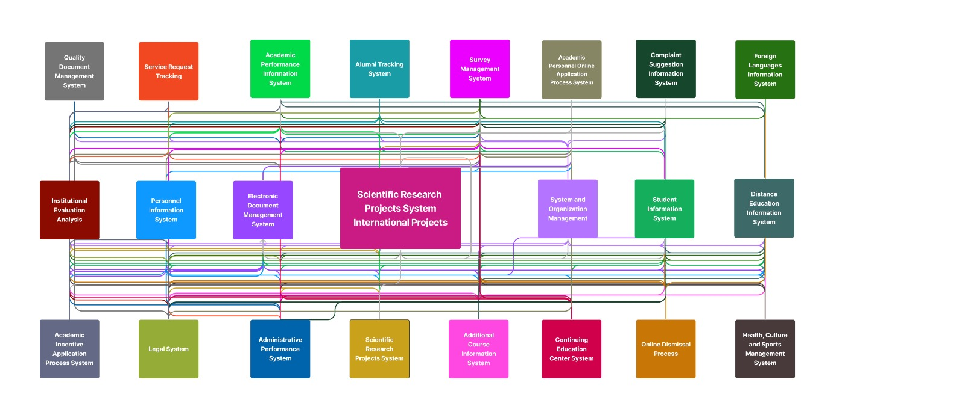

1. **REFERENCES**

Bradford, M. (2015). Modern ERP: Select, Implement, and Use Today's Advanced Business Systems (3rd ed.)

Carlos Coronel, S. M. (2017). Database Systems: Design, Implementation, and Management. Cengage Learning.

Comuzzi, M., & Parhizkar, M. (2017). A methodology for enterprise systems post-implementation change management. Industrial Management & Data Systems.

Fowler, M. (2004). UML Distilled: A Brief Guide to the Standard Object Modeling Language . Addison Wesley and Pearson Education.

Hörnlund, H., & Ålander, J. (2021). User Inclusion during ERP Implementations and its effects on Symbolic Adoption

Larman, C. (n.d.). Applying UML and Patterns: An Introduction to Object-Oriented Analysis and Design.

Moon, Y.B. (2007). Enterprise Resource Planning (ERP): a review of the literature, Int. J. Management and Enterprise Development, Vol. 4, No. 3, pp.235–264.

Motiwalla, L. F., & Thompson, J. (2009). Enterprise Systems for Management. Upper Saddle River, NJ: Pearson Educational

Soliman, M., & Karia, N., 2015. Higher education competitive advantage: enterprise resource planning systems. International Journal of Research in Management & Technology (IJRMT), 5(5), 380-384.